logoFCT_horiz.pdf

**Interacção Pessoa-Máquina**

**2020/2021**

**Evaluation Report**

Stage 5: Heuristic Evaluation

**by**



**Elaborated by: Lab class Nº** P2

41936, Samuel Robalo **Group Nº 13**

44592, Alexander Denisov

50654, Francisco Silva **Professor:**

51095, Daniel Dias Teresa Romão

December 6, 2020

**Considerations**

This evaluation was done by our team to the android application **Foodie** elaborated by the IPM group 14.

Although some features and buttons or functionality were not available or were disregarded during the development of the application, as indicated in the phase 4 report, we still approached the application from the point of view of usability. That is, an element with little or no feedback response would be signalled in our heuristic report.

The stage 4 report was received in 30/11/2020 at 20:17:33 as shown in *Figure 0*.

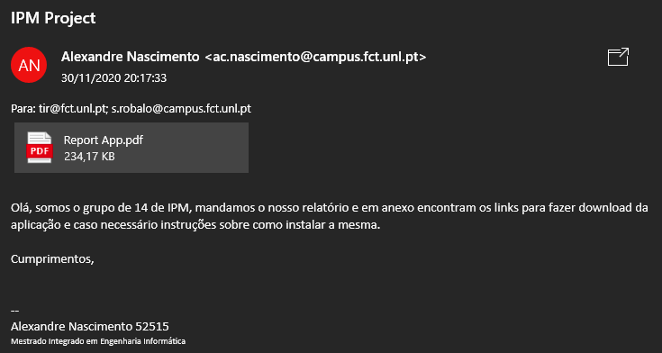

Figure 0: e-mail received

**Heuristic Evaluation**

|  |  |  |  |  |  |  |
| --- | --- | --- | --- | --- | --- | --- |
| **N** | **Problem** | **Heuristic** | **Description** | **Severity** | **Solution** | **Screenshot** |
| **1** | Searching Issue | Flexibility and efficiency of use | Doing a search requires exactly the name of content, e.g.: searching for "Choco", does not return "Chocolate mousse". | **2,25** | Further develop this feature, by adding a search filter. | [Fig. 1](#fig1_4) |
| **2** | Searching Issue | Visibility of system status | If searching finds no results generates a white page, no feedback. | **2,75** | Leave a message that no results were found. | [Fig. 1](#fig1_4) |
| **3** | Textual Description | Match between system and the real world | Ambiguity in categories "dinner", some people call it "supper". | **1** | Modify text to "Dinner/Supper". | [Fig. 2](#fig1_4) |
| **4** | Information | Match between system and the real world | In categories, "Brunch" is not a choice for category some users are used to this definition. | **1,25** | Add "Brunch" as category, search for other culture-based categories. | [Fig. 2](#fig1_4) |
| **5** | Search | Visibility of system status | Search does not provide a result count. | **2,5** | Always display a search result such as "x results found". | [Fig. 3](#fig1_4) |
| **6** | Rating isn't available | Error prevention | Rating in tab is not reachable but is displayed in the bar. | **2,75** | Remove rate from bar or add different text/button colour (light grey) to indicate unavailability. | [Fig. 4](#fig1_4) |
| **7** | Like button N/A | Error prevention | The like button does nothing, has no visible feedback. | **1,75** | Add a popup warning like "functionality not available” or implement functionality. | [Fig. 4](#fig1_4) |
| **8** | Edit profile N/A | Error prevention | The edit button does nothing, the toast is too simple and does not reflect the lack of an implementation. | **1,75** | Add a popup warning like "functionality not available” or implement functionality. | [Fig. 5](#fig5_8) |

|  |  |  |  |  |  |  |
| --- | --- | --- | --- | --- | --- | --- |
| **N** | **Problem** | **Heuristic** | **Description** | **Severity** | **Solution** | **Screenshot** |
| **9** | Log Out N/A | Error prevention | The logout button does nothing, the toast is too simple and does not reflect the lack of an implementation. | **2,5** | Add a popup warning like "functionality not available” or implement functionality. | [Fig. 5](#fig5_8) |
| **10** | Menu Buttons | Aesthetic and minimalist design | All options menus, the 3 vertical dots icon can be misleading. | **1,5** | Change icon to something like: Burger Menu Icon. | [Fig. 5](#fig5_8) |
| **11** | Popups | Aesthetic and minimalist design | Popups (Toast) are too simplistic and disappear fast. | **2** | Make them bigger, opaque and consider time limited/button popups. | [Fig. 6](#fig5_8) |
| **12** | Recipe: No delete option | User control and freedom | Upon submitting a recipe, the is no way to edit or delete it, a bad input might lead user to resubmit. | **3,25** | Make an option or button to allow user to edit or delete unwanted recipe submission. |  |
| **13** | Recipe: Bar Style | Aesthetic and minimalist design | Grey on Dark Grey colour contrast is not ideal and unappealing. | **1,75** | Change colours or add colour schemes/themes. | [Fig. 4](#fig1_4) |
| **14** | Profile: User Image | Aesthetic and minimalist design | Some might consider a square user image on profile as unappealing, does not fit in well with the overall app style or modern app design styles. | **1** | Round the image corners or add a border or frame to make it more appealing. | [Fig. 6](#fig5_8) |
| **15** | App Background | Aesthetic and minimalist design | The white background is always present even when no information to display. | **1,25** | Add a background colour or imagens on Views. | [Fig. 1](#fig1_4) |
| **16** | Text Inputs | Aesthetic and minimalist design | Untreated text on the fields allow Emoji's to be added. | **2,25** | Contextual keyboard limitation on user input. | [Fig. 7](#fig5_8) |
| **17** | No feedback | Error prevention | Pressing Coop recipe menu, does not provide any feedback. | **2,75** | Implement or add a popup/error to inform user what is going on. | [Fig. 8](#fig5_8) |

|  |  |  |  |  |  |  |
| --- | --- | --- | --- | --- | --- | --- |
| **N** | **Problem** | **Heuristic** | **Description** | **Severity** | **Solution** | **Screenshot** |
| **18** | No feedback | Error prevention | Pressing Share recipe menu, does not provide any feedback. | **2,75** | Implement or add a popup/error to inform user what is going on. | [Fig. 8](#fig5_8) |
| **19** | Loading App | Aesthetic and minimalist design | After app launches, lack of intermediate layer, like a presentation or loading screen. | **2,5** | Add a start screen with app logo and/or developer logo or info. |  |
| **20** | Loading App | Visibility of system status | App will process internal information, loading grows with local or remote information, might cause delays. | **2,25** | Add a start/loading screen, for app resources processing, before main screen appears. |  |
| **21** | Recipe: Image | User control and freedom | Forces an image to be added when user might not want to add any image. | **3,25** | Provide alternative like default images within app. | [Fig. 9](#fig9_12) |
| **22** | Recipe: Ingredients Tab | Consistency and standards | Plus, icon misleads user, plus is recognized as adding something, not to be used for listing, does not seem as something to add on the shopping cart. | **1,75** | Add Bullet Point or a border / frame / division around each item. | [Fig. 10](#fig9_12) |
| **23** | No Help or Support | Help and documentation | No information about how to use the app, end user will likely be lost for some time. | **1,75** | Add a help section or configuration menu to assist in optional app features. |  |
| **24** | Text Inputs | Error prevention | Bad text processing allows empty information like a single "space" to be added. | **2,5** | Contextual keyboard limitation on user input. | [Fig. 11](#fig9_12) |
| **25** | On Add Ingredients | Flexibility and efficiency of use | When you finish writing an ingredient and click on "ADD INGREDIENT", the input does not go to the next entry. The same goes for the steps | **2,5** | Make the user input go to the next entry on button click. | [Fig. 12](#fig9_12) |
| **26** | No login | Match between system and the real world | There are multiple users in the app community sharing recipes but no login system. | **2,5** | If the logout is a functionality, the login should also be represented. |  |

|  |  |  |  |  |  |  |
| --- | --- | --- | --- | --- | --- | --- |
| **N** | **Problem** | **Heuristic** | **Description** | **Severity** | **Solution** | **Screenshot** |
| **27** | Shopping Cart Icon | Aesthetic and minimalist design | Shopping cart icon makes no sense in recipe ingredients tab, at least without interactions. | **2** | Implement the functionality or remove the shopping cart icon and change the ingredient list to something like a bullet list. | [Fig. 10](#fig9_12) |
| **28** | Text Inputs | User control and freedom | User is not limited on the amount of text input, on titles, descriptions, etc. | **1,5** | Limited the input fields. | [Fig. 13](#fig13_17) |
| **29** | Searching Issue | Consistency and standards | Inconsistency in the search bar between the "RECIPES" and "SOCIAL" tabs, with too much not clickable empty space. | **1,5** | The search bar in "RECIPES" should be like the one in "SOCIAL", with the filters appearing only on focus. | [Figs. 14, 15](#fig13_17) |
| **30** | Searching Issue | Fitts’ Law | The search button in "RECIPES" is hidden below all the filters, does not provide an efficient usage. The keyboard button does not work. | **3** | There should be a way to finish the search without needing to scroll to the bottom: Pressing enter, or floating search button. | [Fig. 16](#fig13_17) |
| **31** | Profile Space Management | Aesthetic and minimalist design | The profile picture and social counts take too much screen space, impacts the usability of the system, especially on wider screens. | **2,5** | Instead of using fixed values for coordinates / dimensions, makes them dynamic and adapts to the screen size. | [Figs. 17](#fig13_17)[, 18](#fig18_22) |
| **32** | Lack of reversible actions | User control and freedom | The interface does not encourage user exploration. | **2,75** | Add a "Back" navigation button / arrow. |  |
| **33** | Buttons not aligned | Aesthetic and minimalist design | In the ingredient list, the text is positioned higher than the buttons. | **1,5** | Align the plus icon with the text. | [Fig. 10](#fig9_12) |
| **34** | Ingredient not fully visible | Visibility of system status | For new recipes with six ingredients (or another number in different screens), the last ingredient inserted in a new recipe is not fully displayed and the scroll does not work. Probably a result of the previous problem. | **2,5** | The bottom navigation bar is displayed over the view / container, reorder this to be at same view / container level. | [Fig .19](#fig18_22) |
| **N** | **Problem** | **Heuristic** | **Description** | **Severity** | **Solution** | **Screenshot** |
| **35** | Ingredient not inserted | Visibility of system status | For new recipes with seven or more ingredients (or another number in different screens), the last ingredient inserted in a new recipe is not displayed. | **3,5** | The bottom navigation bar is displayed over the view / container, reorder this to be at same view / container level. | [Fig. 20](#fig18_22) |
| **36** | Searching Issue | User control and freedom | No option to change the search query, in case of a typo the user must repeat the whole process. | **3,25** | Make the search bar persist when the results are displayed. | [Fig. 1](#fig1_4) |
| **37** | Adding Folder Issue | Flexibility and efficiency of use | Could not find option to create new folder, outside of saving a recipe. | **2,25** | On the folders tab, allow for the creation of a new folder. |  |
| **38** | Social Issue | Error prevention | On social, when looking through Followed, you can navigate to another user when clicking near "Followed" and "Follower". | **2** | Revise the view and try to fix the bug. | [Fig. 15](#fig13_17) |
| **39** | No Follow/Unfollow | Error prevention | Followed users are displayed, but there is no option to unfollow or follow new user. | **2,25** | Implement and option to follow / unfollow a user. | [Fig. 6](#fig5_8) |
| **40** | No Category Viewing | Flexibility and efficiency of use | Cannot see the categories in which a recipe fits in its own page. | **2,25** | On a recipe's page, display its categories. | [Fig. 4](#fig1_4) |
| **41** | On Add Recipe | Error prevention | On process of adding recipe app sometimes crashes. | **3,5** | Constrain Flow of processes to prevent Android from freeing memory and killing application | [Fig. 21](#fig18_22) |

|  |  |  |  |  |  |  |
| --- | --- | --- | --- | --- | --- | --- |
| **N** | **Problem** | **Heuristic** | **Description** | **Severity** | **Solution** | **Screenshot** |
| **42** | Search | Visibility of system status | On invalid search nothing shows up, but you still can click on Person Profile. | **2,5** | Revise the view and try to fix the bug. | [Fig. 1](#fig1_4) |
| **43** | Add Recipe | User control and freedom | Too many Checkboxes. | **1,75** | Allow user to input text or select option with options. | [Fig. 2](#fig1_4) |
| **44** | Social | Consistency and standards | After selection of following and then swiping, the Recipes and Social buttons disappear. | **3,25** | Make swipe action to return to previous state/screen. | [Figs. 22](#fig18_22)[, 23](#fig23) |
| **45** | Coop Option | Match between system and the real world | Unclear on what "coop" means in this context. | **1** | Use a less ambiguous expression, provide informative popup or proper feedback. | [Fig. 8](#fig5_8) |

**Figures**

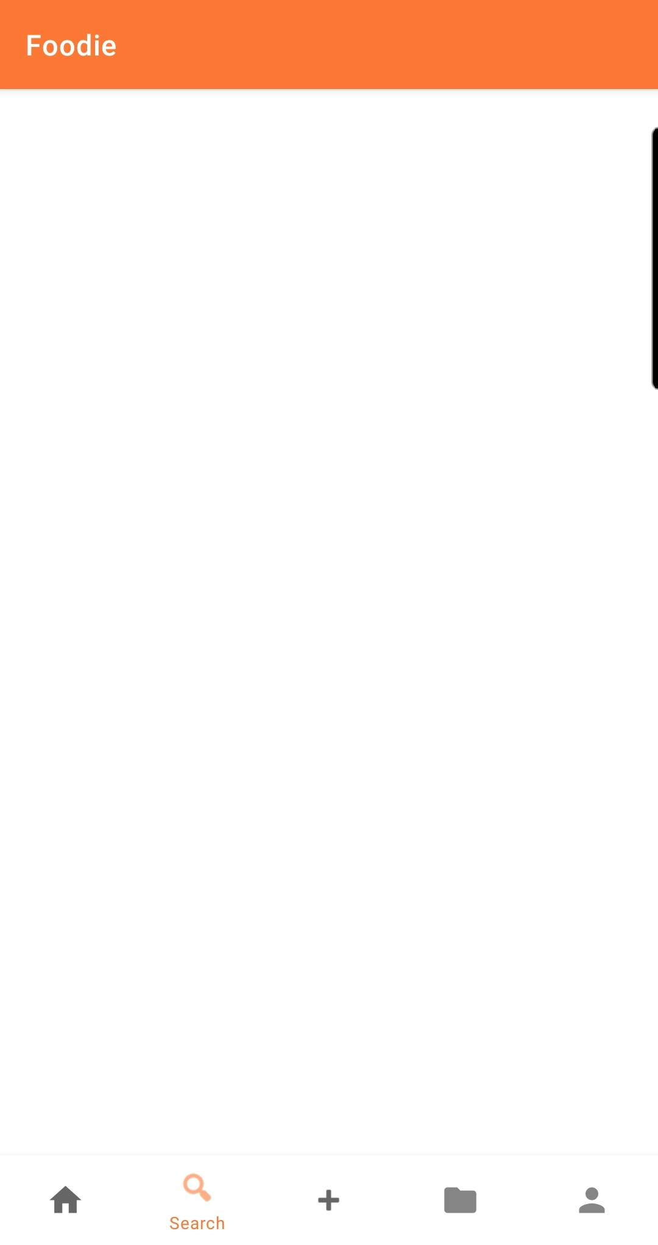

Figure 1

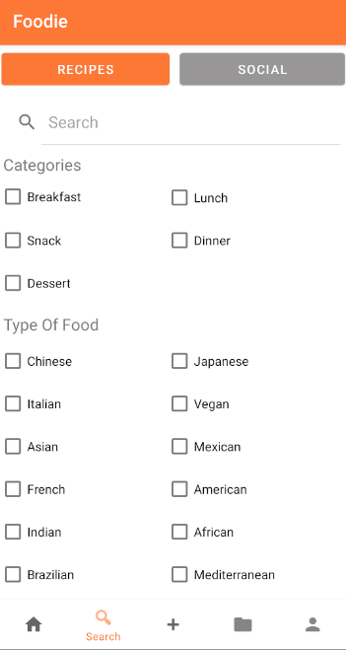

Figure 2

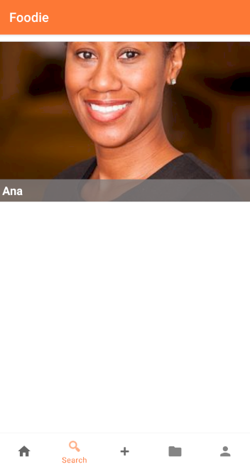

Figure 3

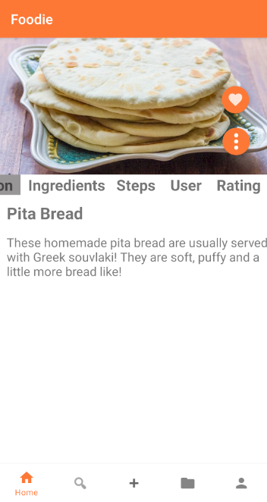

Figure 4

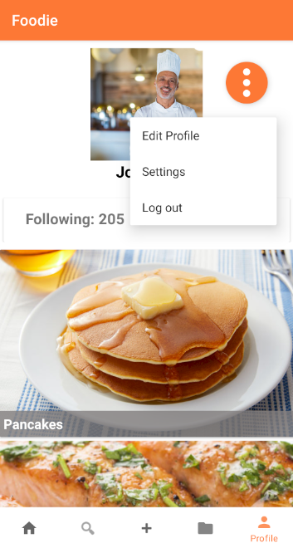

Figure 5

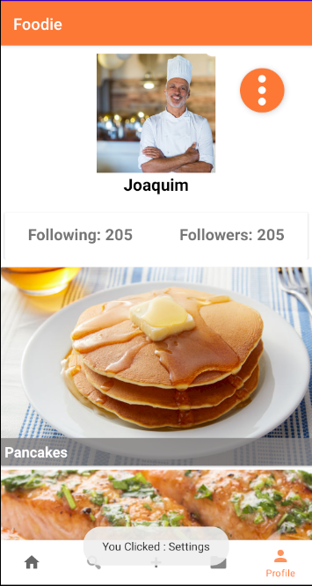

Figure 6

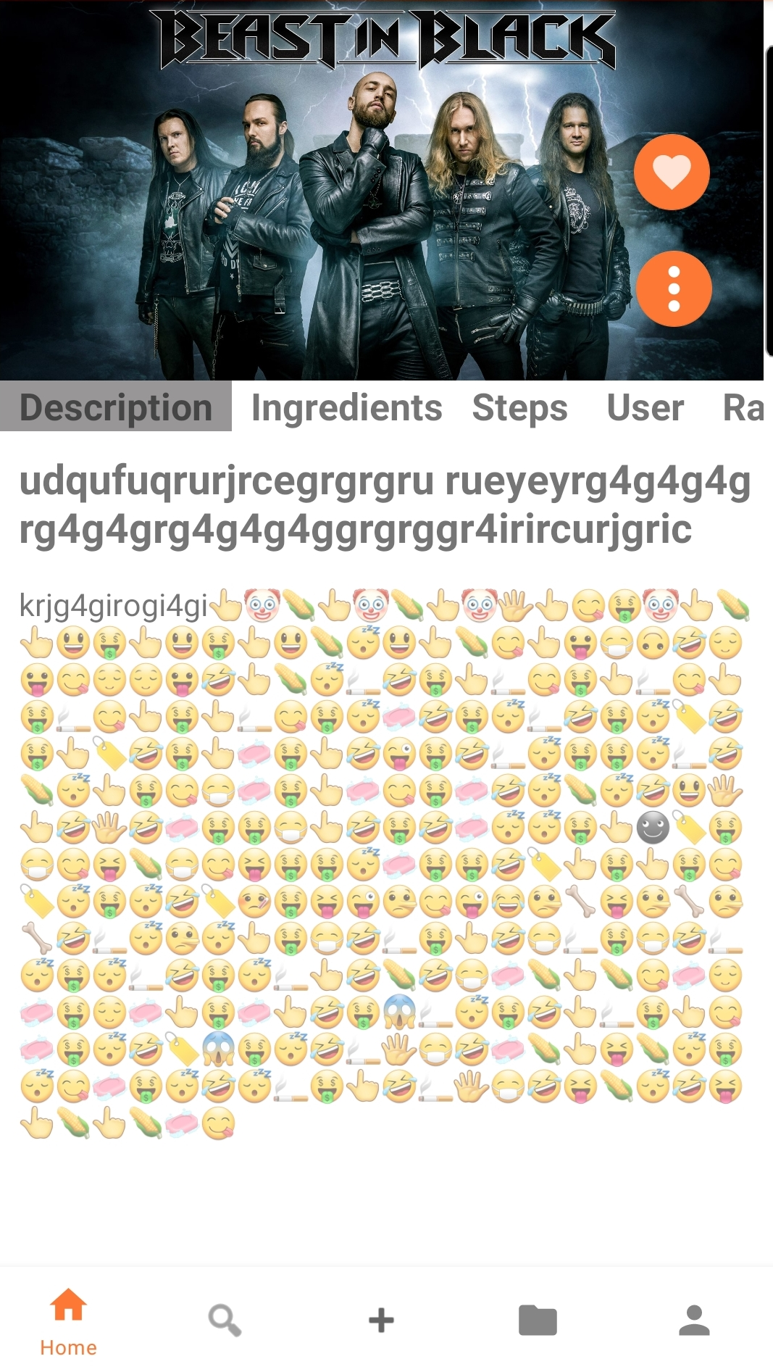

Figure 7

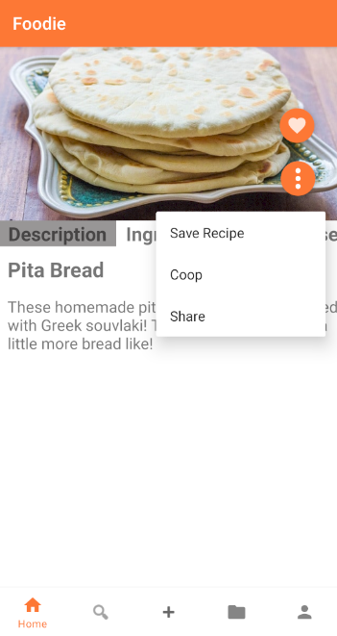

Figure 8

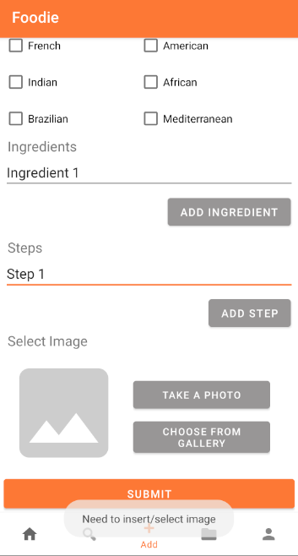

Figure 9

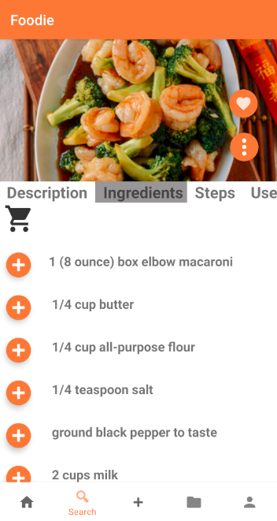

Figure 10

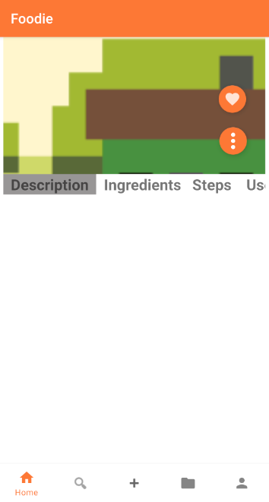

Figure 11

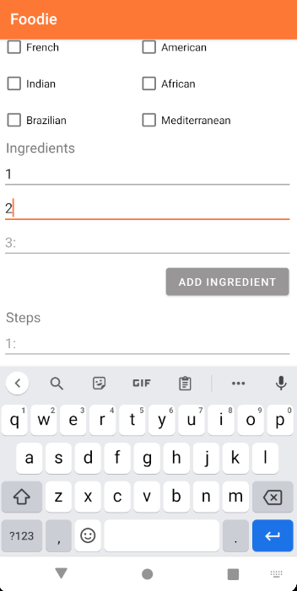

Figure 12

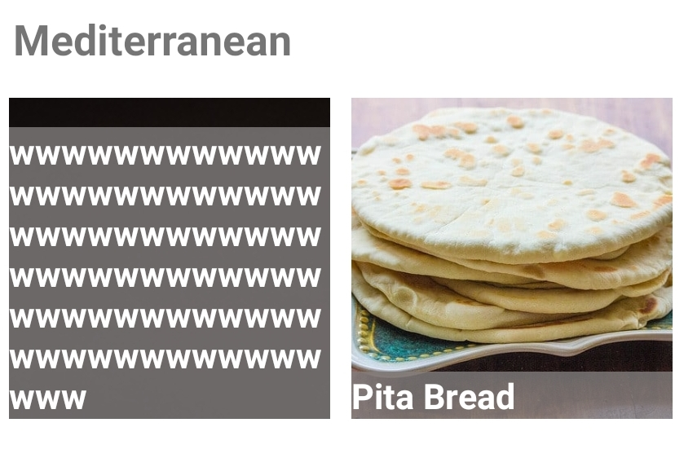

Figure 13

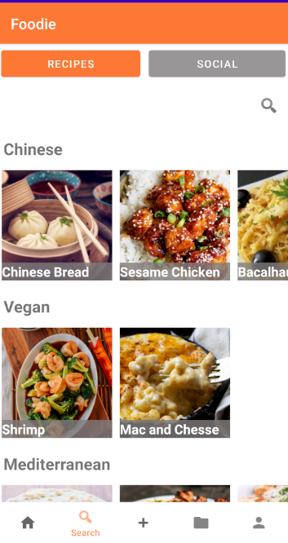

Figure 14

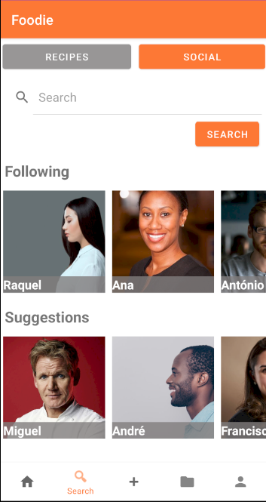

Figure 15

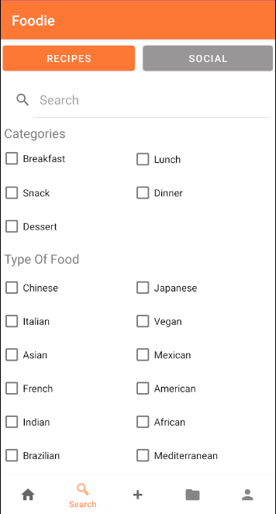

Figure 16

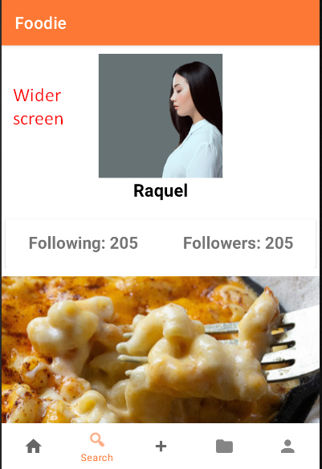

Figure 17

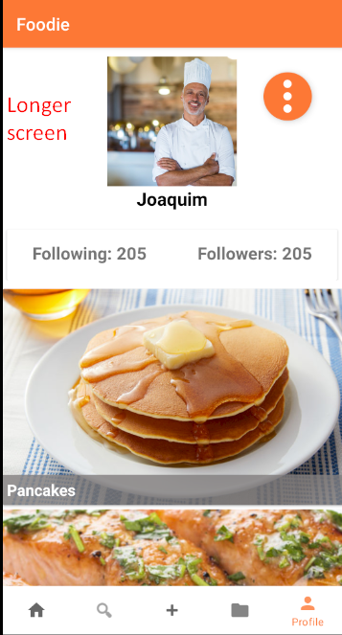

Figure 18

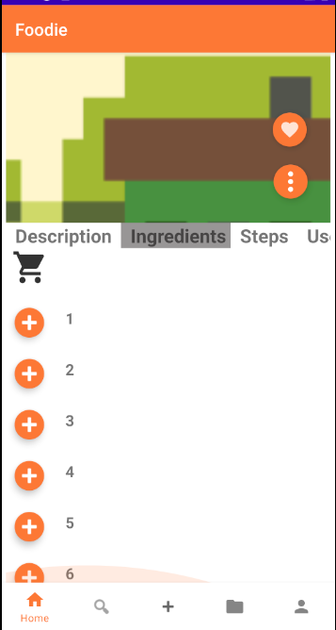

Figure 19

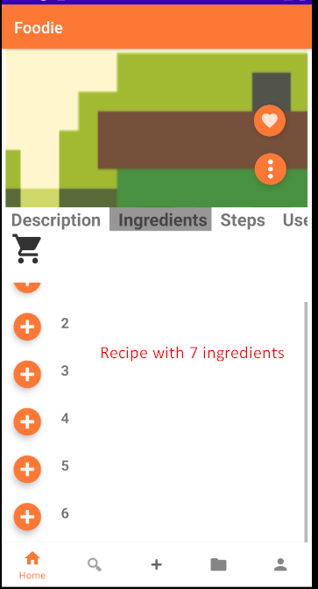

Figure 20

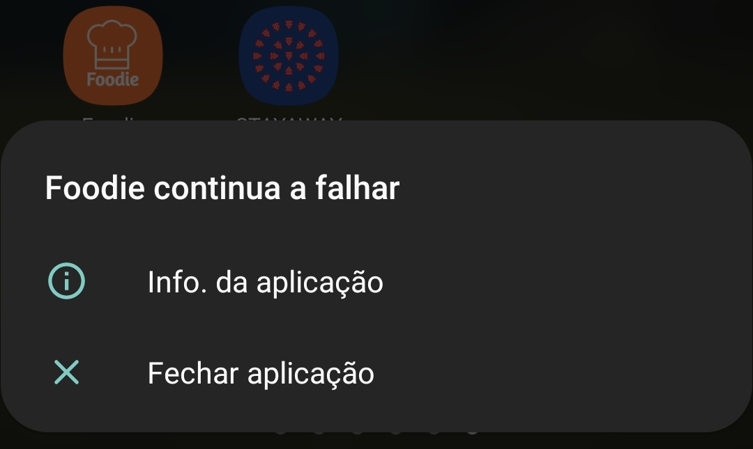

Figure 21

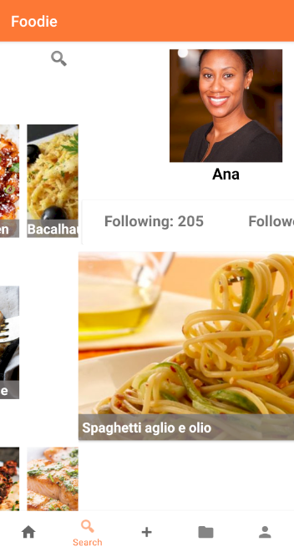

Figure 22

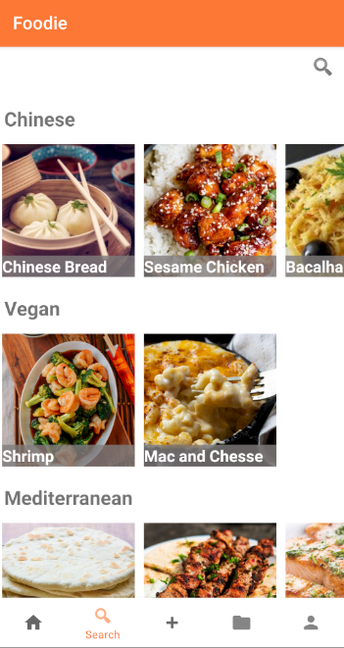

Figure 23

**Observations**

A mobile application should have a storyboard that starts by showing the user a loading screen, while the system preloads the app's resources. Followed by a login system, if any. Or, optionally, the user may be redirected into the application's main screen as an anonymous user (for some extra freedom). This mitigates the problem of older smartphones taking too long to load, which causes a brief crash when opening the app.

We consider that the home view, where the recipes are displayed, should be limited to a defined amount or, preferably, lazy loading techniques should be implemented to avoid the slow loading of the images of all recipes at start-up.

The same view could also be ordered by rating, even if the classification system is not currently implemented.

**Conclusions**

The concept of the project is interesting.

The bottom menu is useful, simple, and clean for the end user. The layout of the app seems adequate, although we consider it lacking in presentation and style.